
Sri Lanka Institute of Information Technology

Year 2 Semester 1
Lab Sheet 07

<IT24101654>
<HASARINDA W.D.Y.L.>

Probability and Statistics - IT2120
B.Sc. (Hons) in Information Technology
Lab Sheet 07

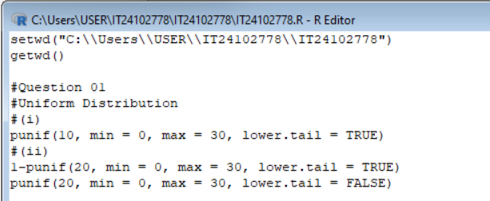
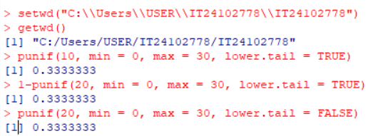
Question 01

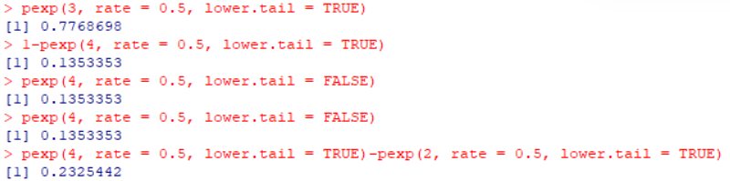
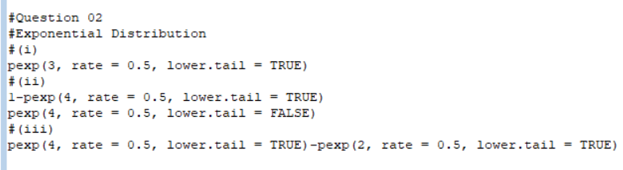
Question 02

Question 03
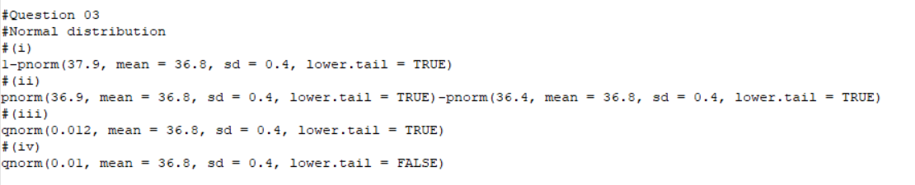
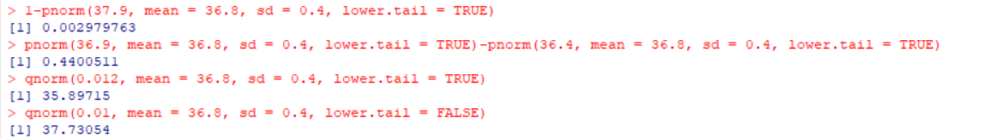
Exercise
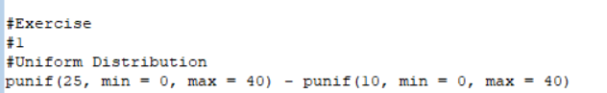
Question 01

Question 02
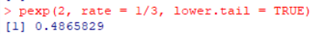

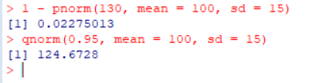
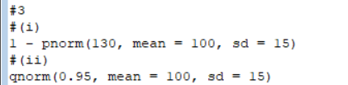
Question 03

